Materials:
- Banner template (see pages below)
- Coloring utensils
- Scissors
- Hole punch
- String, yarn or ribbon for hanging
Directions:
- Print out banner template.
- Cut out the flags.
- Color each letter your hometown team’s colors.
- Discuss and jot down personal therapy goals on the flags.
- Punch holes in the upper corners of each flag.
- Lay out the flags in order.
- Run the string through the holes on the flags.
- Hang up your banner to display your team spirit!

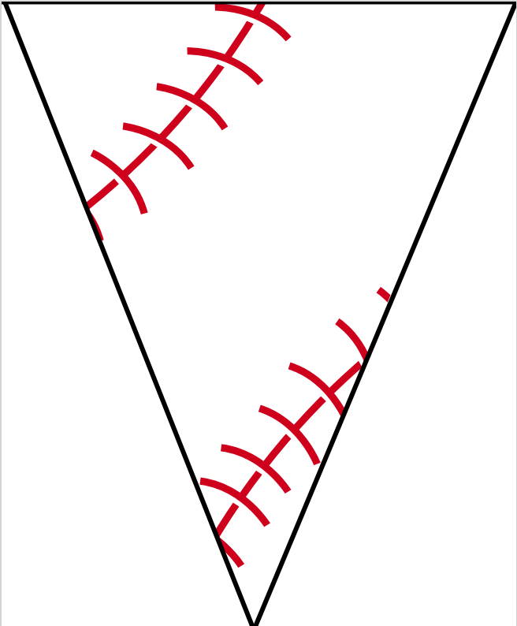

B

A

S

E

B

A

L

L

