Ingredients:
- Celery sticks
- Cream cheese
- Pretzels
- Raisins
- Plates
Directions:
- Gather your ingredients.
- Cut celery stick into 2x10cm lengths.
- Fill each celery stick with cream cheese.
- Place two pretzels in the cream cheese to make butterfly wings.
- Place three raisins along the length of the celery underneath the wings.
- Break two small pieces of a pretzel and place above the whole pretzels to make antennae.
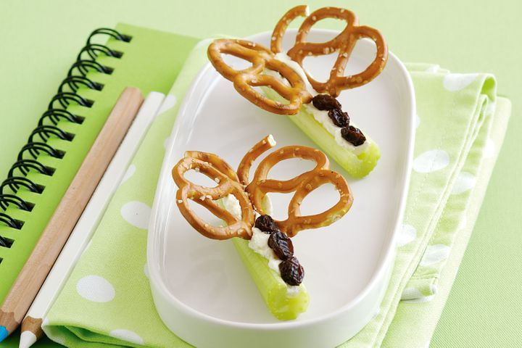
- Enjoy your snack!

