Materials:
- Empty toilet paper rolls
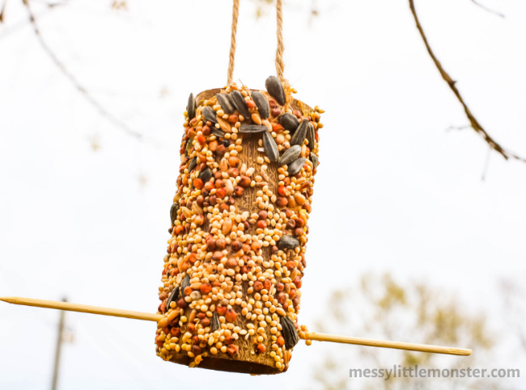
- Peanut butter
- Bird seed
- String
- Scissors
- Bamboo skewer
- Butterknife
Directions:
- Gather your materials.
- Prepare the bird seed by adding to a tray that is larger than the toilet paper rolls.
- Use scissors to create a small set of holes at the top of the toilet roll tube.
- Thread the string through the two holes and tie it in place.
- Use scissors to create another small set of holes towards the bottom of the toilet roll tube.
- Push the bamboo skewer through to make a resting perch.
- Using the butterknife, spread a thin layer of peanut butter over the cardboard tube.
- Immediately after applying the peanut butter, roll the tube in bird seed.
- Press bird seed in any open spots.
- Hang your peanut butter bird feeder up outdoors.
- Wait for the birds to come!

